**Virtual Networking with DNS resolution**

**Project Architecture:**

**Azure Services Used:**

Resource Groups, Virtual Machines, PowerShell, ARM Templates, Network Security Groups, Virtual Networks, Subnets, Private DNS Zone and DNS Zones.

**Detailed Steps:**

Step 1: Provisioned a Virtual Network named az104-04-vnet1 and associated it with Resource Group az104-04-rg1. Both the Virtual Network and Resource Group were deployed in the East US region.

Step 2: Within the address space configuration of the Virtual Network az104-04-vnet1, I allocated an IPv4 address block. Specifically, I reserved the range 10.40.0.0/20-10.40.15.255, which provides a pool of 4,096 usable addresses.

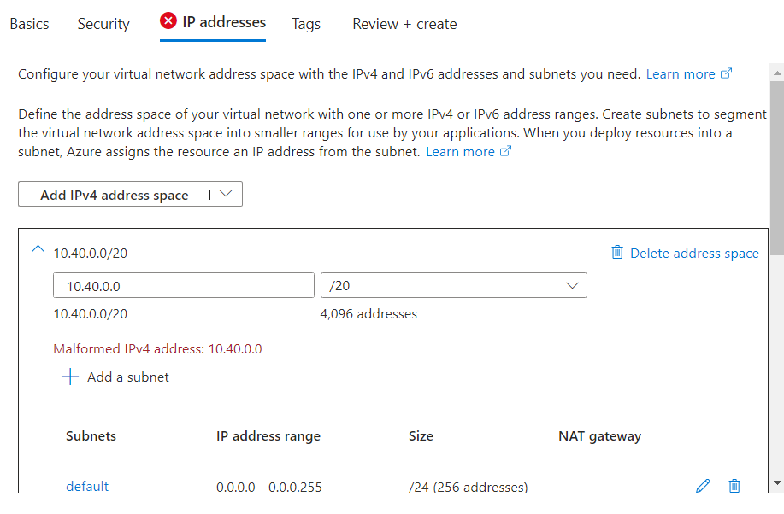

Step 3: Within the address space configuration of the Virtual Network az104-04-vnet1, I allocated an IPv4 address block. Specifically, I reserved the range 10.40.0.0/20-10.40.15.255, which provides a pool of 4,096 usable addresses.

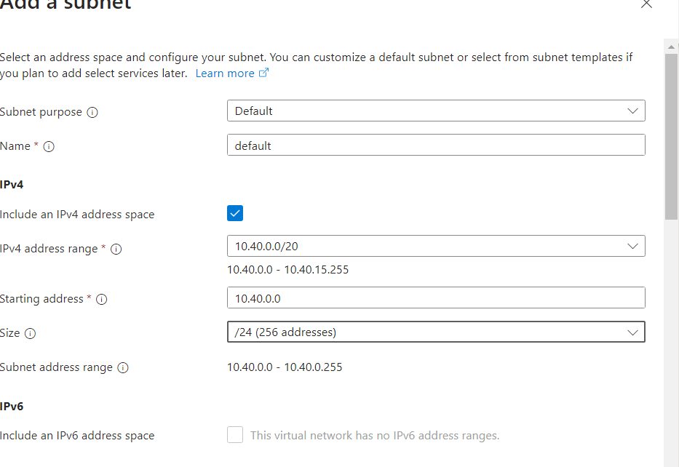

Step 4: Here, I have uploaded and deployed an ARM Template using PowerShell.

Executed the following PowerShell commands to deploy the ARM Template:

PS /home/kiran> $rgName = 'az104-04-rg1'

PS /home/kiran> New-AzResourceGroupDeployment `

>> -ResourceGroup $rgName `

>> -TemplateFile $HOME/az104-04-vms-loop-template.json `

>> -TemplateParameterFile $HOME/az104-04-vms-loop-parameters.json

In the image below, the Template has been deployed successfully.

Step 5: The Network Interface Card (NIC) associated with VM0 (nic0) was previously configured to dynamically obtain an IP address via DHCP. In this step, I migrated the IP assignment to a static configuration and provisioned a Public IP address with Basic SKU using dynamic assignment.Graphical user interface, text, application, email

Step 6: Following the previous step of assigning a Public IP (Basic SKU, Dynamic) to nic0 of VM0, I also configured a static internal IP address. This ensures that the VM retains its internal IP address even after a restart or reboot. A static internal IP simplifies management and avoids potential disruptions caused by dynamic IP reassignment.Graphical user interface, application, Word

Step 7: On VM1, I transitioned the internal IP assignment for nic1 to a static configuration. Additionally, I provisioned a Public IP address (Basic SKU with dynamic assignment) for nic1.Graphical user interface, application, Word

Step 8: Attempted an RDP connection to VM0. However, the connection failed due to default Azure security rules blocking inbound traffic to VMs. To establish connectivity, I implemented the following steps:

1. Created Network Security Group (NSG) Rules: These rules allow specific inbound traffic to reach the VMs.
2. Configured the NSG Rules for RDP access: This ensures RDP connections can reach the VMs on port 3389.
3. Associated the NSG Rules with the VM's Network Interface Cards (NICs): This links the security rules to the specific VMs that require RDP access.

Step 9: Within Resource Group az104-04-rg1 (East US region), I created a Network Security Group (NSG) rule allowing RDP access to VMs. This rule permits inbound traffic on port 3389 (RDP) to reach VMs associated with the NSG. It's important to note that allowing any incoming traffic poses a security risk. In production environments, consider restricting RDP access to specific source IP addresses for enhanced security.AllowRDPInbound NSG Rule:

Source – Any

Source Port Ranges – Any

Destination – Any

Service – RDP

Destination Port – 3389

Action – Allow

Priority – 300

Step 10: Following the creation of the NSG rule, I associated it with both Network Interface Cards (NICs) of the VMs.

Step 11: Following the association of the NSG rule with the VM's NICs, I was able to successfully establish an RDP connection to the VM.

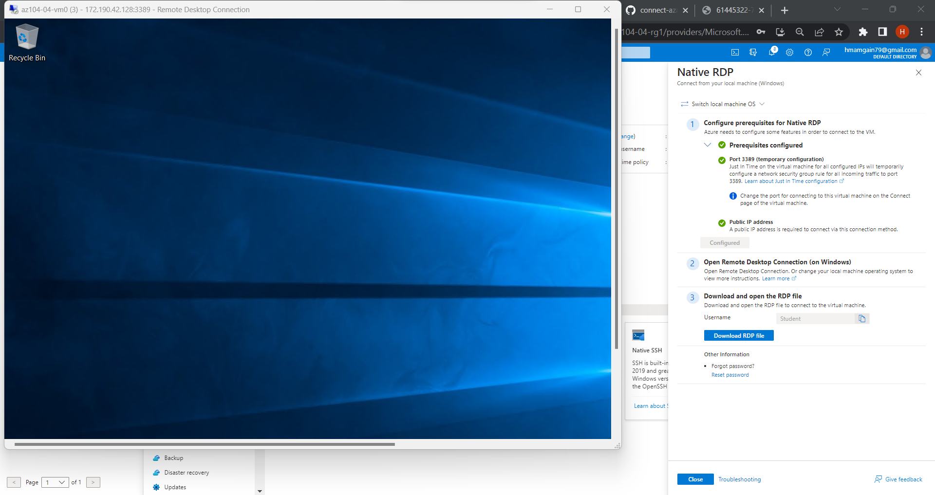

Step 12: Internal Name Resolution with Azure Private DNS

We've successfully accessed the VMs, but memorizing IP addresses can get tedious. To make things easier, let's configure Private DNS for internal name resolution. This allows VMs within the same virtual network (az104-04-vnet1) to find each other using friendly names instead of IP addresses. For internal name resolution, I have created a Private DNS Zone. With the following details.

Subscription - Azure subscription 1

Resource group - az104-04-rg1

Resource group location- eastus

Name - vminternaldns.org

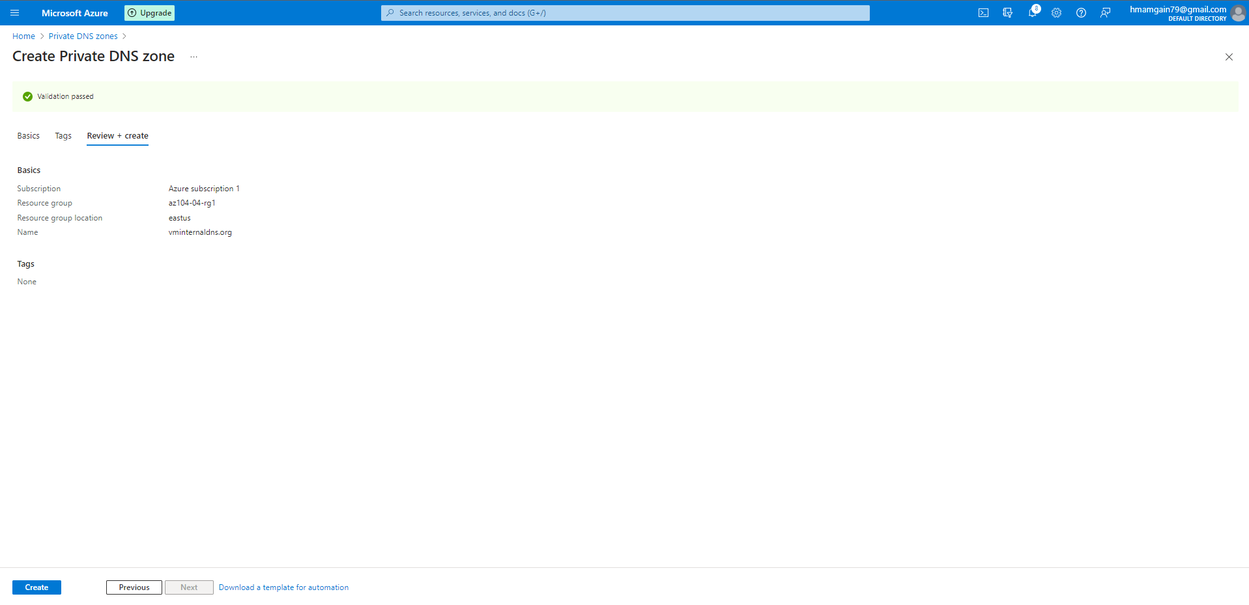

Step 13: We just created a magic bridge called a Virtual Network Link. This link connects our virtual network (az104-04-vnet1) to the private DNS zone. Here's the cool part: VMs inside the network can now look up domain names within the private zone, all without needing the public internet!

This keeps things secure and efficient. VMs can find each other by name, ditching the hassle of memorizing IP addresses.

Step 14: To validate internal name resolution functionality after establishing the Virtual Network link, I utilized the nslookup command on a machine within the virtual network (az104-04-vnet1). nslookup VM_Name.Domain_Name (replacing placeholders with the actual VM name and internal domain). A successful lookup, returning the internal IP address associated with VM1, confirms that VMs can now locate each other using hostnames within the private DNS zone.

* nslookup az104-04-vm1.vminternaldns.org

Server: UnKnown

Address: 168.63.129.16

Non-authoritative answer:

Name: az104-04-vm1.vminternaldns.org

Address: 10.40.1.4

* nslookup az104-04-vm0.vminternaldns.org

Server: UnKnown

Address: 168.63.129.16

Non-authoritative answer:

Name: az104-04-vm0.vminternaldns.org

Address: 10.40.0.4

Step 15: The Private DNS zone, functions exclusively within the virtual network. To enable global accessibility of VMs over the internet, I've additionally configured a separate public DNS zone. This public zone will allow external users to resolve VM hostnames using the internet, facilitating remote access to the VMs.

Creating a DNS Zone, using this service. With the following details:

Resource group - az104-04-rg1

Resource group location - eastus

Name - vmexternal.org

Step 16: After creating the DNS Zone, I have created an ‘A Record’ set for VM0.

A record set is a collection of DNS records that share the same name and type. Record sets are used to manage DNS records for a domain name or subdomain within a DNS zone.

TTL – ‘ Time to Live’ This determines how long the DNS record will be cached by DNS servers.

Record Type – A

TTL – 1 hour

Public IP - 172.190.42.128

Step 17: An ‘A Record’ set for VM1.

Record Type – A

TTL – 1 hour

Public IP - 172.190.43.246

Step 18: Public DNS records for the VMs are now in place.

Step 19: Verifying internet reachability for VMs, I successfully resolved their hostnames using Azure Cloud Shell; this functionality is enabled by Azure's highly available nameservers, ensuring reliable translation of VM hostnames to public IP addresses.

Nameservers are a critical component of the Domain Name System (DNS) that translate domain names into IP addresses. In simple terms, nameservers are servers that are responsible for storing information about a domain name and its associated IP addresses.

* nslookup az104-04-vm1.vmexternal.org ns1-37.azure-dns.com.

Server: ns1-37.azure-dns.com.

Address: 150.171.10.37#53

Name: az104-04-vm1.vmexternal.org

Address: 172.190.43.246

* nslookup az104-04-vm0.vmexternal.org ns1-37.azure-dns.com.

Server: ns1-37.azure-dns.com.

Address: 150.171.10.37#53

Name: az104-04-vm0.vmexternal.org

Address: 172.190.42.128

4 Nameservers available _

ns1-37.azure-dns.com.

ns2-37.azure-dns.net.

ns3-37.azure-dns.org.

ns4-37.azure-dns.info.

